# For this homework assignment, I will be using **LINDO** to calculate the problems.

1). A). Find the distance of the shortest path from G to C in the graph below.

Objective function is max c as to find the shortest path to c from g, and the constraints are the code between ST and END below from the screenshot in which they are the distances from one vertex to another. For example, h-g <= 3 is interpreted as the distance from h to g is 3.

The shortest path from g to c is 16.

**Copy of Code**

max c

ST

g=0

h-g<=3

d-g<=2

g-e<=7

e-d<=25

d-e<=9

e-b<=10

b-h<=9

a-h<=4

e-f<=2

b-a<=8

a-f<=5

f-a<=10

b-f<=7

c-b<=4

c-f<=3

f-d<=18

d-c<=3

END

**Result (Output)**

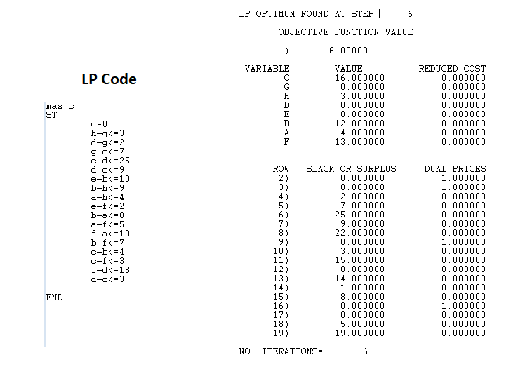

B). Find the distances of the shortest paths from G to all other vertices.

The objective function is max a+b+c+d+e+f+h to find the shortest paths from g to all the vertices. Although we will get the sum of all the shortest paths, but that doesn’t matter because we only care about the shortest path in each vertex from g, which is underneath the objective function value in the picture below. The constraints the code between ST and END below from the screenshot in which they are the distances from one vertex to another. For example, h-g <= 3 is interpreted as the distance from h to g is 3.

The shortest path from G to all the other vertices:

|  |  |  |  |  |  |  |
| --- | --- | --- | --- | --- | --- | --- |
| A | B | C | D | E | F | H |
| 7 | 12 | 16 | 2 | 19 | 17 | 3 |

The value “76” is meaningless because that is the sum of all the shortest paths, but the shortest paths have been listed below from A to H.

**Copy of Code**

max a+b+c+d+e+f+h

ST

g=0

h-g<=3

d-g<=2

g-e<=7

e-d<=25

d-e<=9

e-b<=10

b-h<=9

a-h<=4

e-f<=2

b-a<=8

a-f<=5

f-a<=10

b-f<=7

c-b<=4

c-f<=3

f-d<=18

d-c<=3

END

**Result (Output)**

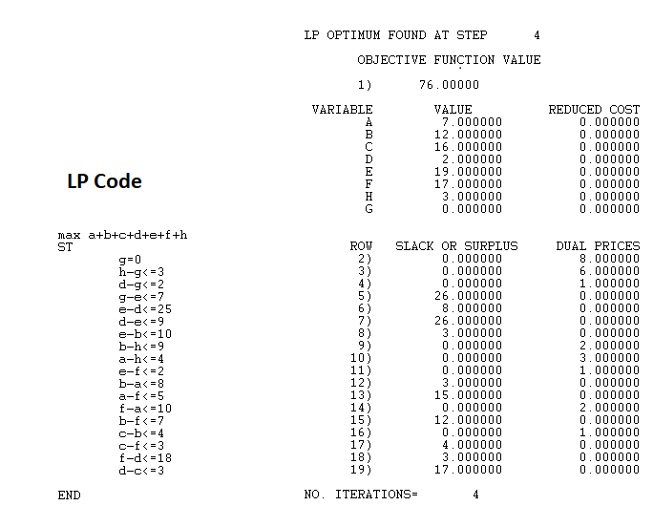

2). Formulate the problem as a linear program with an objective function and all constraints. Determine the optimal solution for the linear program using any software you want. Include a copy of the code and output. What are the optimal numbers of ties of each type to maximize profit?

|  |  |  |  |  |
| --- | --- | --- | --- | --- |
| Type | Selling Price | Labor Cost | Material Cost | Profit |
| Silk | 6.7 | 0.75 | 2.5 | 3.45 |
| Polyester | 3.55 | 0.75 | 0.48 | 2.32 |
| Blend 1 | 4.31 | 0.75 | 0.75 | 2.81 |
| Blend 2 | 4.81 | 0.75 | 0.81 | 3.25 |

**Formulate the problem as linear program**

max 3.45s + 2.32p + 2.81b + 3.25c

ST

0.125s <= 1000 : This is for Silk

0.08p + 0.05b + 0.03c <= 2000 : This is for Polyester

0.05b + 0.07c <= 1250 : This is for Cotton

s <= 7000; s >= 6000

p <= 14000; p >= 10000

b <= 16000; b >= 13000

c <= 8500; c >= 6000

**Copy of Code**

max 3.45s + 2.32p + 2.81b + 3.25c

ST

0.125s <= 1000

0.08p + 0.05b + 0.03c <= 2000

0.05b + 0.07c <= 1250

s <= 7000

s >= 6000

p <= 14000

p >= 10000

b <= 16000

b >= 13000

c <= 8500

c >= 6000

END

**Result (output)**

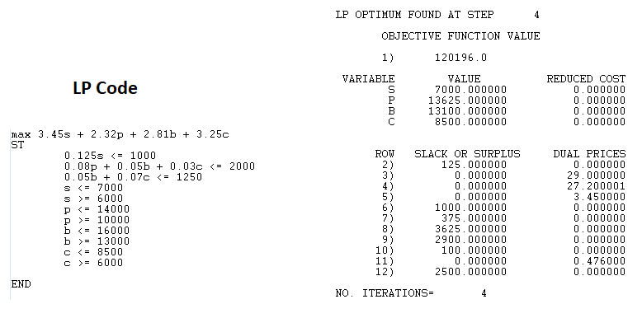

**The maximum profit is $120,196.00 from producing 7,000 units of silk ties, 13,625 units of polyester ties, 13,100 units of Blend 1, and 8,500 units of Blend 2.**

3). A). Determine the number of refrigerators to be shipped from the plants to the warehouses and then warehouses to retailers to minimize the cost. Formulate the problem as a linear program with an objective function and all constraints. Determine the optimal solution for the linear program using any software you want. What are the optimal shipping routes and minimum cost?

**Objective Function:**

Minimize transshipment costs (Z) = 10P1W1 + 15P1W2 + 11P2W1 + 8P2W2 + 13P3W1 + 8P3W2 + 9P3W3 + 14P4W2 + 8P4W3 + 5W1R1 + 6W1R2 + 7W1R3 + 10W1R4 + 12W2R3 + 8W2R4 + 10W2R5 + 14W2R6 + 14W3R4 + 12W3R5 + 12W3R6 + 6W3R7

**Constraints:**

**Constraints on Plants (P):**  **Constraints on Retailers (R):**

P1W1 + P1W2 <= 150 W1R1 >= 100

P2W1 + P2W2 <= 450 W1R2 >= 150

P3W1 + P3W2 + P3W3 <= 250 W1R3 + W2R3 >= 100

P4W2 + P4W3 <= 150 W1R4 + W2R4 + W3R4 >= 200

W2R5 + W3R5 >= 200

W2R6 + W3R6 >= 150

W3R7 >= 100

**Constraints on Warehouses (W) since nothing should be stored in the end**

W1R1 + W1R2 + W1R3 + W1R4 – P1W1 – P2W1 – P3W1 = 0

W2R3 + W2R4 + W2R5 + W2R6 – P1W2 – P2W2 – P3W2 – P4W2 = 0

W3R4 + W3R5 + W3R6 + W3R7 – P3W3 – P4W3 = 0

**Non-negativity Constraints:**

P1W1 >= 0 W1R1 >= 0 W3R5 >= 0

P1W2 >= 0 W1R2 >= 0 W3R6 >= 0

P2W1 >= 0 W1R3 >= 0 *W3R7 >= 0*

P2W2 >= 0 W1R4 >= 0

P3W1 >= 0 W2R3 >= 0

P3W2 >= 0 W2R4 >= 0

P3W3 >= 0 W2R5 >= 0

P4W2 >= 0 W2R6 >= 0

P4W3 >= 0 W3R4 >= 0

**LP Code**

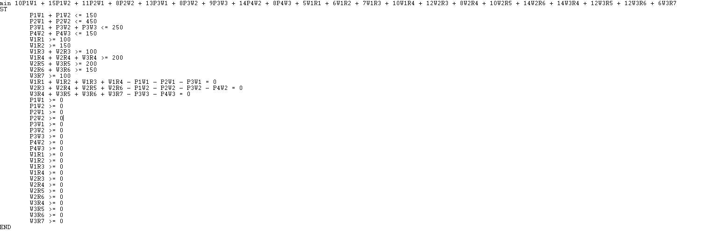

**Copy of Code**

min 10P1W1 + 15P1W2 + 11P2W1 + 8P2W2 + 13P3W1 + 8P3W2 + 9P3W3 + 14P4W2 + 8P4W3 + 5W1R1 + 6W1R2 + 7W1R3 + 10W1R4 + 12W2R3 + 8W2R4 + 10W2R5 + 14W2R6 + 14W3R4 + 12W3R5 + 12W3R6 + 6W3R7

ST

P1W1 + P1W2 <= 150

P2W1 + P2W2 <= 450

P3W1 + P3W2 + P3W3 <= 250

P4W2 + P4W3 <= 150

W1R1 >= 100

W1R2 >= 150

W1R3 + W2R3 >= 100

W1R4 + W2R4 + W3R4 >= 200

W2R5 + W3R5 >= 200

W2R6 + W3R6 >= 150

W3R7 >= 100

W1R1 + W1R2 + W1R3 + W1R4 - P1W1 - P2W1 - P3W1 = 0

W2R3 + W2R4 + W2R5 + W2R6 - P1W2 - P2W2 - P3W2 - P4W2 = 0

W3R4 + W3R5 + W3R6 + W3R7 - P3W3 - P4W3 = 0

P1W1 >= 0

P1W2 >= 0

P2W1 >= 0

P2W2 >= 0

P3W1 >= 0

P3W2 >= 0

P3W3 >= 0

P4W2 >= 0

P4W3 >= 0

W1R1 >= 0

W1R2 >= 0

W1R3 >= 0

W1R4 >= 0

W2R3 >= 0

W2R4 >= 0

W2R5 >= 0

W2R6 >= 0

W3R4 >= 0

W3R5 >= 0

W3R6 >= 0

W3R7 >= 0

END

**Result (Output)**

The minimum cost is **$17,100**

|  |  |  |  |
| --- | --- | --- | --- |
| Route | Quantity | Price per item | Cost |
| P1W1 | 150 | 10 | 1500 |
| P2W1 | 200 | 11 | 2200 |
| P2W2 | 250 | 8 | 2000 |
| P3W2 | 150 | 8 | 1200 |
| P3W3 | 100 | 9 | 900 |
| P4W3 | 150 | 8 | 1200 |
| W1R1 | 100 | 5 | 500 |
| W1R2 | 150 | 6 | 900 |
| W1R3 | 100 | 7 | 700 |
| W2R4 | 200 | 8 | 1600 |
| W2R5 | 200 | 10 | 2000 |
| W3R6 | 150 | 12 | 1800 |
| W3R7 | 100 | 6 | 600 |
| Total | 2000 |  | 17,100 |

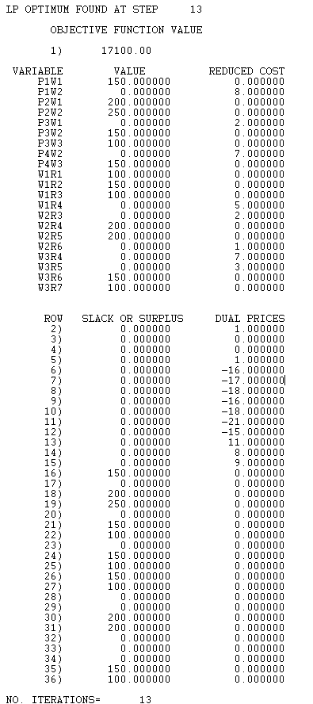

3). B). Due to old infrastructure Warehouse 2 is going to close eliminating all of the associated routes. What is the optimal solution for this modified model? Is it feasible to ship all the refrigerators to either warehouse 1 or 3 and then to the retailers without using warehouse 2? Why or why not?

This modified model is not feasible or no solution to that because, according to the graph, there are lots of retailers like R5, R6, and R7 cannot be reached through warehouse 1 but only 3 if warehouse 2 is closed. Since P1 and P2 can only access to warehouse 1, those retailers cannot be reached without warehouse 2. It also breaks the constraint for R5 if the warehouse 2 is closed because if only P3 and P4 are able supply R5, R6, and R7 with their supply capacity of 400 in combined, they will not be enough to supply all those retailers. P3 and P4 have a combined supply capacity of 400 but R5, R6, and R7 have a combined demand of 450. Though P3 and P4 can supply R6 and R7 sufficiently, (400-250=150), that leaves the combined supply capacity with only 150 but R5 demands for 200, therefore without warehouse 2, P3 and P4 will not be able to supply the combined demand of R5, R6, and R7. We can also test this hypothesis by modify the code and run it on LINDO, the program resulted an error.

Here’s the output result:

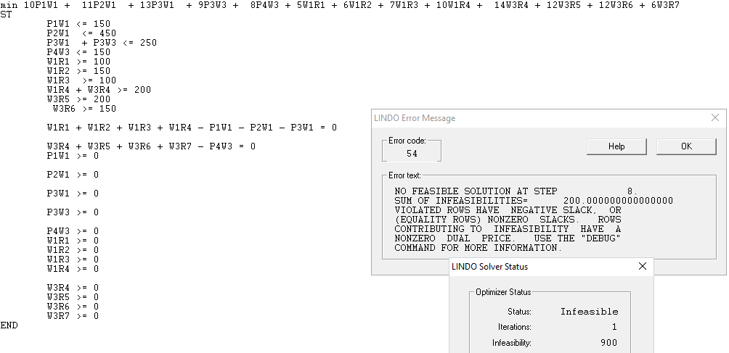

**Copy of Code**

min 10P1W1 + 11P2W1 + 13P3W1 + 9P3W3 + 8P4W3 + 5W1R1 + 6W1R2 + 7W1R3 + 10W1R4 + 14W3R4 + 12W3R5 + 12W3R6 + 6W3R7

ST

P1W1 <= 150

P2W1 <= 450

P3W1 + P3W3 <= 250

P4W3 <= 150

W1R1 >= 100

W1R2 >= 150

W1R3 >= 100

W1R4 + W3R4 >= 200

W3R5 >= 200

W3R6 >= 150

W3R7 >= 100

W1R1 + W1R2 + W1R3 + W1R4 - P1W1 - P2W1 - P3W1 = 0

W3R4 + W3R5 + W3R6 + W3R7 - P3W3 - P4W3 = 0

P1W1 >= 0

P2W1 >= 0

P3W1 >= 0

P3W3 >= 0

P4W3 >= 0

W1R1 >= 0

W1R2 >= 0

W1R3 >= 0

W1R4 >= 0

W3R4 >= 0

W3R5 >= 0

W3R6 >= 0

W3R7 >= 0

END

3). C). Instead of closing Warehouse 2 management has decide to keep a portion of it open but limit shipments to 100 refrigerators per week. Is this feasible? If so what is the optimal solution when warehouse 2 is limited to 100 refrigerators?

The modified model is feasible and the optimal solution for the minimized cost when warehouse 2 is limited to 100 refrigerators is 18,300. Here are the results for the modified model with LINDO:

**LP Code**

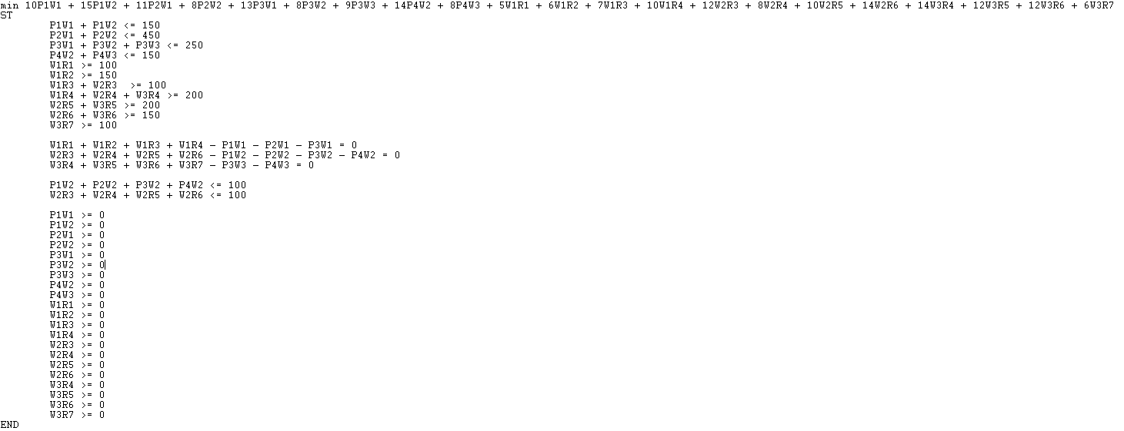

**Copy of Code**

min 10P1W1 + 15P1W2 + 11P2W1 + 8P2W2 + 13P3W1 + 8P3W2 + 9P3W3 + 14P4W2 + 8P4W3 + 5W1R1 + 6W1R2 + 7W1R3 + 10W1R4 + 12W2R3 + 8W2R4 + 10W2R5 + 14W2R6 + 14W3R4 + 12W3R5 + 12W3R6 + 6W3R7

ST

P1W1 + P1W2 <= 150

P2W1 + P2W2 <= 450

P3W1 + P3W2 + P3W3 <= 250

P4W2 + P4W3 <= 150

W1R1 >= 100

W1R2 >= 150

W1R3 + W2R3 >= 100

W1R4 + W2R4 + W3R4 >= 200

W2R5 + W3R5 >= 200

W2R6 + W3R6 >= 150

W3R7 >= 100

W1R1 + W1R2 + W1R3 + W1R4 - P1W1 - P2W1 - P3W1 = 0

W2R3 + W2R4 + W2R5 + W2R6 - P1W2 - P2W2 - P3W2 - P4W2 = 0

W3R4 + W3R5 + W3R6 + W3R7 - P3W3 - P4W3 = 0

P1W2 + P2W2 + P3W2 + P4W2 <= 100

W2R3 + W2R4 + W2R5 + W2R6 <= 100

P1W1 >= 0

P1W2 >= 0

P2W1 >= 0

P2W2 >= 0

P3W1 >= 0

P3W2 >= 0

P3W3 >= 0

P4W2 >= 0

P4W3 >= 0

W1R1 >= 0

W1R2 >= 0

W1R3 >= 0

W1R4 >= 0

W2R3 >= 0

W2R4 >= 0

W2R5 >= 0

W2R6 >= 0

W3R4 >= 0

W3R5 >= 0

W3R6 >= 0

W3R7 >= 0

END

**Result (Output)**

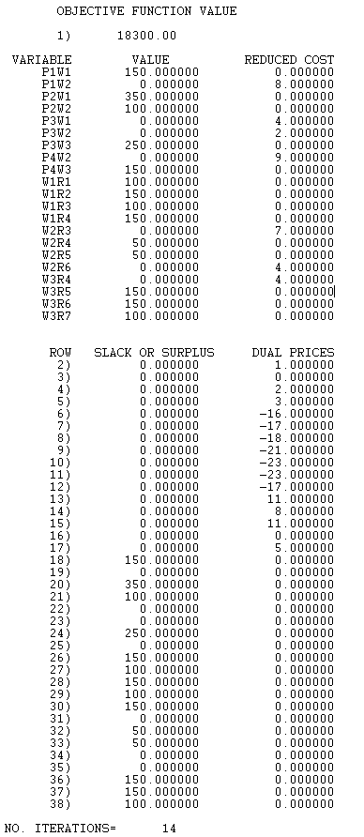

4). A). V = [1, 5, 10, 25] and A = 202.

Objective function is the min of V1 + V2 + V3 + V4. The constraints are they should be non-negatives and 1V1 + 5V2 + 10V3 + 25V4 = 202. The minimum number of coins for making a change is 10 with two coins of 1’s and eight coins of 25’s.

**Copy of Code**

min V1 + V2 + V3 + V4

ST

1V1 + 5V2 + 10V3 + 25V4 = 202

V1>=0

V2>=0

V3>=0

V4>=0

END

GIN V1

GIN V2

GIN V3

GIN V4

**Result (Output)**

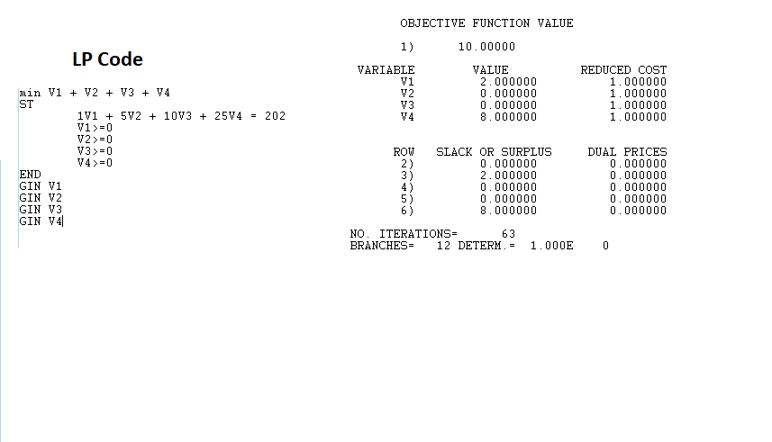

B). V = [1, 3, 7, 12, 27] and A = 293

Objective function is the min of V1 + V2 + V3 + V4 + V5. The constraints are they should be non-negatives and 1V1 + 3V2 + 7V3 + 12V4 + 27V5 = 293. The minimum number of coins for making a change is 14 with two coins of 7’s, three coins of 12’s, and nine coins of 27’s.

**Copy of Code**

min V1 + V2 + V3 + V4 + V5

ST

1V1 + 3V2 + 7V3 + 12V4 + 27V5 = 293

V1>=0

V2>=0

V3>=0

V4>=0

V5>=0

END

GIN V1

GIN V2

GIN V3

GIN V4

GIN V5

**Result (Output)**

